Advanced C programming
Module 1
Assignment Questions:
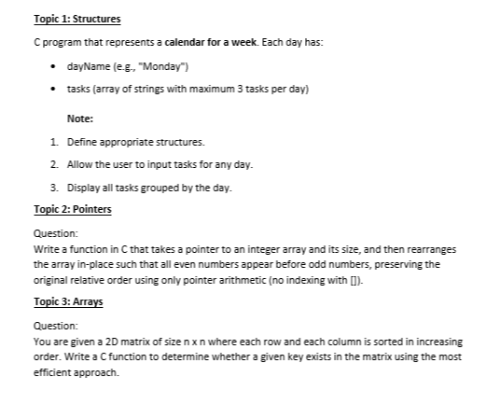
Answers:

Topic 1: Structures

Program: Weekly Task Calendar

Algorithm
- Create a structure for storing day name, tasks, and task count.
- Create an array of structures for 7 days.
- Display all days.
- Ask the user to select a day.
- Validate the day input.
- Ask for number of tasks.
- Validate task limit (maximum 3).
- Store tasks using fgets().
- Repeat until user exits.
- Display all tasks grouped by day.
Program
#include <stdio.h>
#include <string.h>
struct Day
{
char dayName[20];
char tasks[3][50];
int taskCount;
};
int main()
{
struct Day week[7] = {
{"Monday", {}, 0},
{"Tuesday", {}, 0},
{"Wednesday", {}, 0},
{"Thursday", {}, 0},
{"Friday", {}, 0},
{"Saturday", {}, 0},
{"Sunday", {}, 0}
};
int choice, newTasks, i;
char continueChoice;
do
{
printf("\n========== DAYS OF WEEK ==========\n");
for(i = 0; i < 7; i++)
{
printf("%d. %s\n", i + 1, week[i].dayName);
}
while(1)
{
printf("\nSelect a day (1-7): ");
scanf("%d", &choice);
if(choice >= 1 && choice <= 7)
{
break;
}

printf("Invalid day! Enter between 1 and 7.\n");
}
choice--;
printf("\nSelected Day: %s\n", week[choice].dayName);
printf("Existing tasks: %d\n", week[choice].taskCount);
if(week[choice].taskCount == 3)
{
printf("Maximum task limit reached!\n");
}
else
{
while(1)
{
printf("How many new tasks to add? ");
printf("(Enter 0 to cancel): ");
scanf("%d", &newTasks);
if(newTasks == 0)
{
printf("Task addition cancelled.\n");
break;
}

else if(newTasks < 0)
{
printf("Negative numbers not allowed.\n");
}
else if(week[choice].taskCount + newTasks > 3)
{
printf("Maximum 3 tasks only allowed.\n");
printf("You can add only %d more task(s).\n",
3 - week[choice].taskCount);
}
else
{
getchar();
for(i = 0; i < newTasks; i++)
{
printf("Enter task %d: ",
week[choice].taskCount + 1);
fgets(
week[choice].tasks[week[choice].taskCount],
50,
stdin
);
week[choice].tasks[week[choice].taskCount]
[strcspn(
week[choice].tasks[week[choice].taskCount],
"\n"
)] = '\0';
week[choice].taskCount++;
}
printf("Tasks added successfully!\n");
break;
}
}
}
while(1)
{
printf("\nDo you want to continue? (y/n): ");
scanf(" %c", &continueChoice);
if(continueChoice == 'y' ||
continueChoice == 'Y' ||
continueChoice == 'n' ||
continueChoice == 'N')
{
break;
}
printf("Invalid choice! Enter y or n only.\n");
}
} while(continueChoice == 'y' ||
continueChoice == 'Y');
printf("\n======= WEEKLY TASK CALENDAR =======\n");
for(i = 0; i < 7; i++)
{
int j;
printf("\n%s:\n", week[i].dayName);
if(week[i].taskCount == 0)
{
printf("No tasks assigned.\n");
}
else
{
for(j = 0; j < week[i].taskCount; j++)
{
printf("%d. %s\n",
j + 1,
week[i].tasks[j]);
}
}
}
return 0;
}
O/P:
========== DAYS OF WEEK ==========
1. Monday
2. Tuesday
3. Wednesday
4. Thursday
5. Friday
6. Saturday
7. Sunday

Select a day (1-7): 1

Selected Day: Monday
Existing tasks: 0
How many new tasks to add? (Enter 0 to cancel): 1
Enter task 1: To complete watching session
Tasks added successfully!

Do you want to continue? (y/n): y

========== DAYS OF WEEK ==========
1. Monday
2. Tuesday
3. Wednesday
4. Thursday
5. Friday
6. Saturday
7. Sunday

Select a day (1-7): 2

Selected Day: Tuesday
Existing tasks: 0
How many new tasks to add? (Enter 0 to cancel): 1
Enter task 1: To complete Assignment
Tasks added successfully!

Do you want to continue? (y/n): y

========== DAYS OF WEEK ==========
1. Monday
2. Tuesday
3. Wednesday
4. Thursday
5. Friday
6. Saturday
7. Sunday

Select a day (1-7): 3

Selected Day: Wednesday
Existing tasks: 0
How many new tasks to add? (Enter 0 to cancel): 1
Enter task 1: To attend viva
Tasks added successfully!

Do you want to continue? (y/n): y

========== DAYS OF WEEK ==========
1. Monday
2. Tuesday
3. Wednesday
4. Thursday
5. Friday
6. Saturday
7. Sunday

Select a day (1-7): 5

Selected Day: Friday
Existing tasks: 0
How many new tasks to add? (Enter 0 to cancel): 0
Task addition cancelled.

Do you want to continue? (y/n): y

========== DAYS OF WEEK ==========
1. Monday
2. Tuesday
3. Wednesday
4. Thursday
5. Friday
6. Saturday
7. Sunday

Select a day (1-7): 1

Selected Day: Monday
Existing tasks: 1
How many new tasks to add? (Enter 0 to cancel): 3
Maximum 3 tasks only allowed.
You can add only 2 more task(s).
How many new tasks to add? (Enter 0 to cancel): 0
Task addition cancelled.

Do you want to continue? (y/n): n

======= WEEKLY TASK CALENDAR =======

Monday:
1. To complete watching session

Tuesday:
1. To complete Assignment

Wednesday:
1. To attend viva

Thursday:
No tasks assigned.

Friday:
No tasks assigned.

Saturday:
No tasks assigned.

Sunday:
No tasks assigned.

Program Ended Successfully.

=== Code Execution Successful ===

Proof:
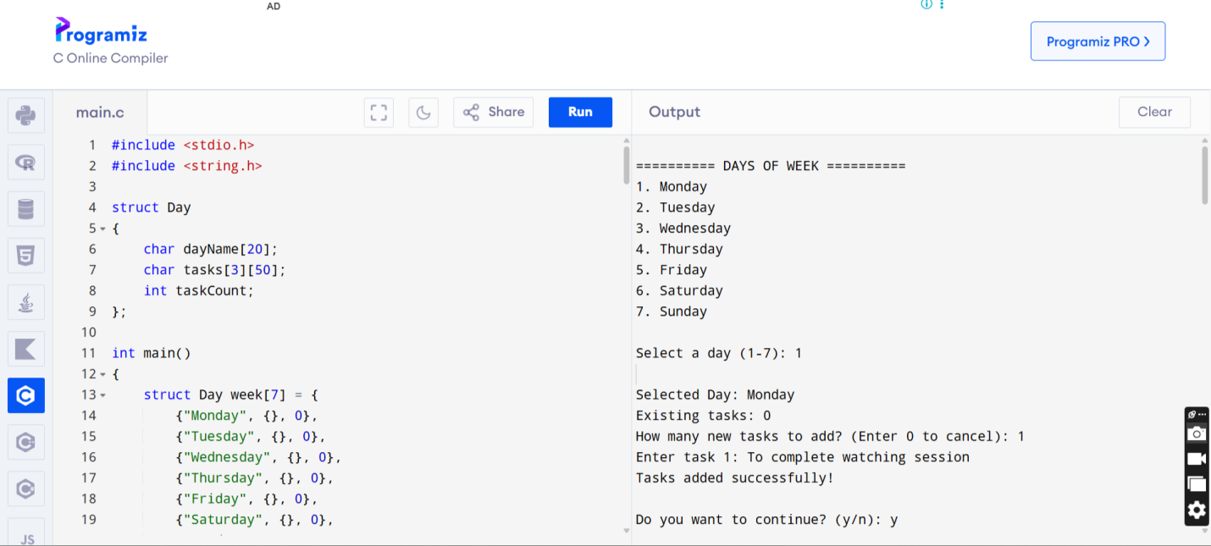

Topic 2: Pointers

Program: Rearrange Array with Even Numbers Before Odd Numbers

Algorithm
- Read array elements.
- Traverse the array using pointers.
- Store even numbers first in a temporary array.
- Store odd numbers next.
- Copy temporary array back to original array.
- Display rearranged array.

Program

#include <stdio.h>

void rearrange(int *arr, int size)

{

int temp[size];

int *p = arr;

int *t = temp;

int i;

/* STORE EVEN NUMBERS */

while(p < arr + size)

{

if(*p % 2 == 0)

{

*t = *p;

t++;

}

p++;

}

/* STORE ODD NUMBERS */

p = arr;

while(p < arr + size)

{

if(*p % 2 != 0)

{

*t = *p;

t++;

}

p++;

}

/* COPY BACK TO ORIGINAL ARRAY */

for(i = 0; i < size; i++)

{

*(arr + i) = temp[i];

}

}

int main()

{

int arr[100];

int size;

int i;

printf("Enter number of elements: ");

scanf("%d", &size);

printf("Enter array elements:\n");

for(i = 0; i < size; i++)

{

scanf("%d", &arr[i]);

}

printf("\nOriginal Array:\n");

for(i = 0; i < size; i++)

{

printf("%d ", arr[i]);

}

rearrange(arr, size);

printf("\n\nRearranged Array:\n");

for(i = 0; i < size; i++)

{

printf("%d ", arr[i]);

}

return 0;

}

O/P:

Enter number of elements: 5

Enter array elements:

2 3 4 5 6

Original Array:

2 3 4 5 6

Rearranged Array:

2 4 6 3 5

=== Code Execution Successful ===

Proof:

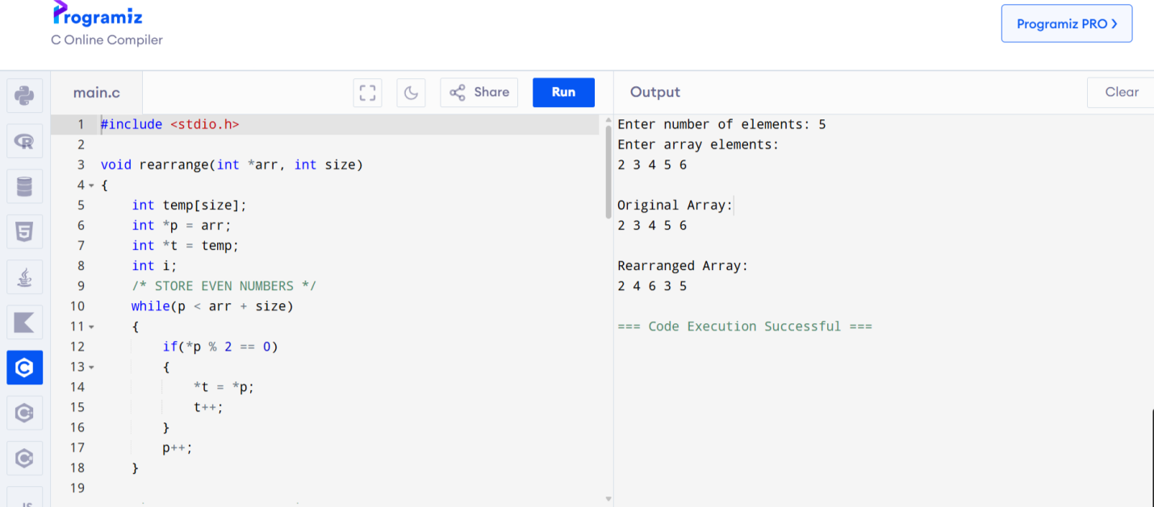

Topic 3: Arrays

Program: Search an Element in a Sorted Matrix

Staircase Search Algorithm:
- Read the matrix elements.
- Start search from the top-right corner.
- If key equals current element, display found.
- If key is smaller, move left.
- If key is larger, move down.
- Repeat until key is found or search ends.

Program:
#include <stdio.h>
int searchMatrix(int matrix[10][10], int n, int key)
{
int row = 0;
int col = n - 1;
while(row < n && col >= 0)
{
if(matrix[row][col] == key)
{
return 1;
}
else if(matrix[row][col] > key)
{
col--;
}
else
{
row++;
}
}
return 0;
}
int main()
{
int matrix[10][10];
int n;
int i, j;
int key;
char choice;
printf("Enter order of matrix: ");
scanf("%d", &n);
printf("Enter matrix elements:\n");
for(i = 0; i < n; i++)
{
for(j = 0; j < n; j++)
{
scanf("%d", &matrix[i][j]);
}
}
do
{
printf("\nEnter key element to search: ");
scanf("%d", &key);
if(searchMatrix(matrix, n, key))
{
printf("Key found in matrix.\n");
}
else
{
printf("Key not found in matrix.\n");
}
while(1)
{
printf("\nDo you want to search again? (y/n): ");
scanf(" %c", &choice);
if(choice == 'y' || choice == 'Y' ||
choice == 'n' || choice == 'N')
{
break;
}
printf("Invalid choice! Enter y or n only.\n");
}
} while(choice == 'y' || choice == 'Y');
printf("\nProgram Ended Successfully.\n");
return 0;
}
O/P:
Enter order of matrix: 3
Enter matrix elements:
1 2 3
4 5 6
7 8 9

Enter key element to search: 3
Key found in matrix.

Do you want to search again? (y/n): y

Enter key element to search: 10
Key not found in matrix.

Do you want to search again? (y/n): n

Program Ended Successfully.

Proof:
